**How to Parameterize Requests**

**1. Open openweathermap.org page and observe API requests**

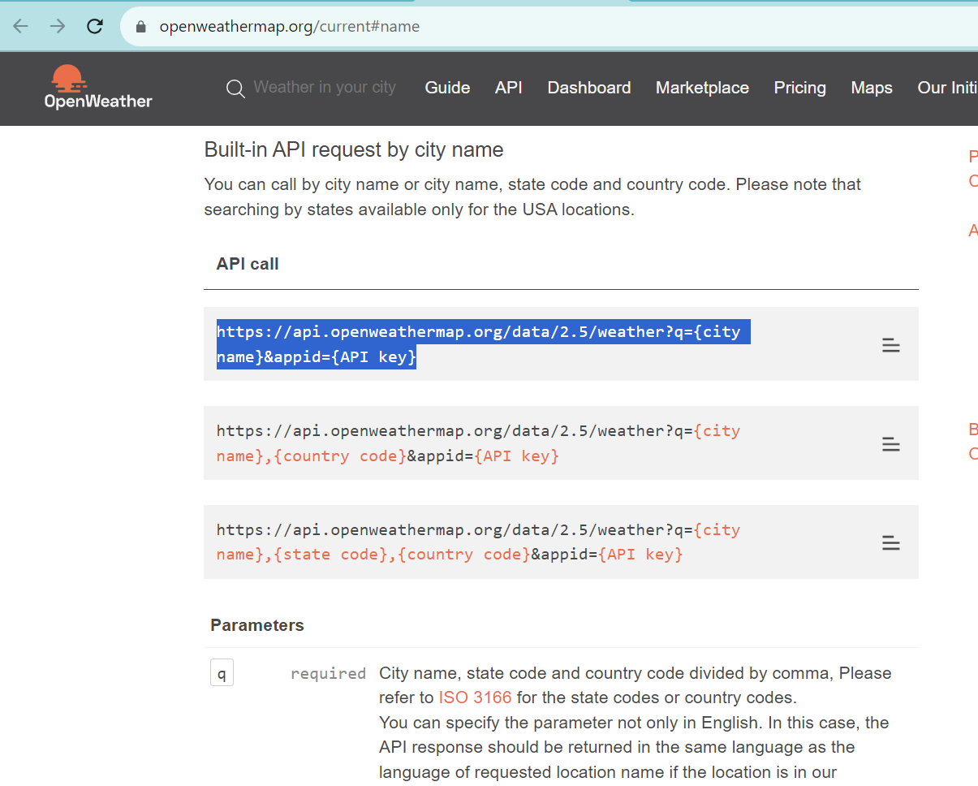

**2. Create a GET Request and add the above copied link, replace city name and API key with parameters**

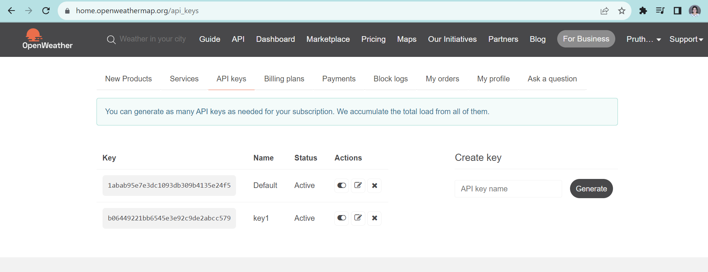

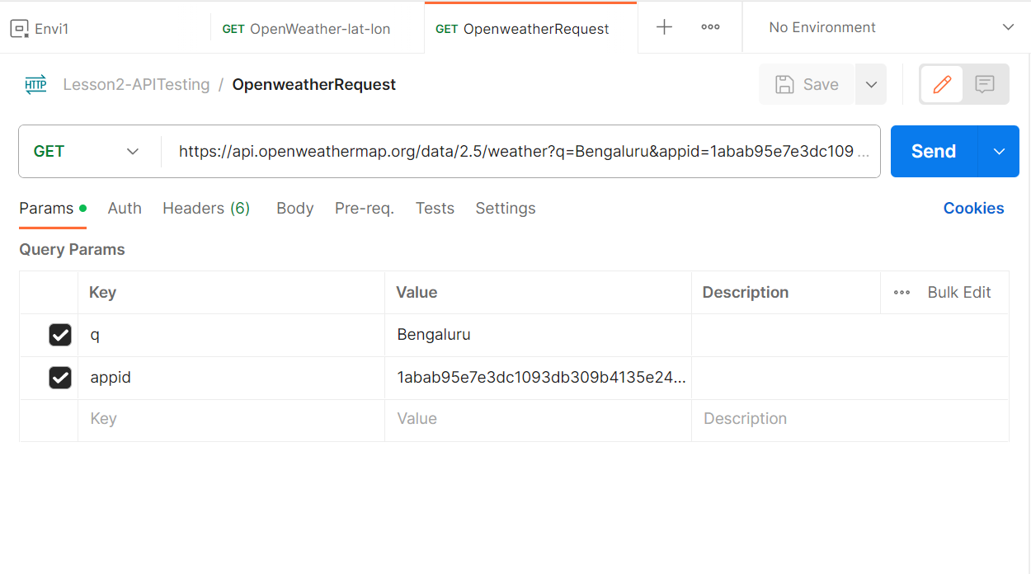

**3. Save and Send. View response**

